**Master Geometry Dash on Your PC: A Step-by-Step Guide to Using Bluestacks**

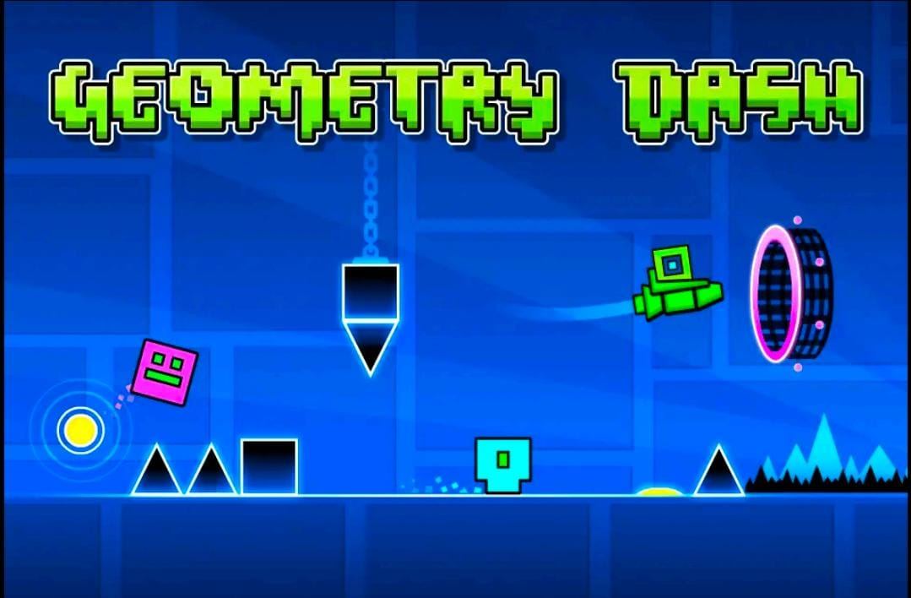

Geometry Dash has captivated millions of players Geometry Dash has captivated millions of players worldwide, offering an intense, rhythm-based platformer experience that combines fast reflexes with strategic timing. The game is usually played on mobile devices, but many players prefer the precision and larger display available on a PC. To achieve the best experience, using an Android emulator like Bluestacks can bring Geometry Dash to your desktop. In this guide, we cover everything you need to know about playing Geometry Dash on [geometry dash bluestacks](https://geometerydashh.com/geometry-dash-on-pc/) your PC with Bluestacks, from installation to optimization.

**Why Play Geometry Dash on PC?**

Playing Geometry Dash on a PC offers significant advantages, such as a bigger screen, precise keyboard controls, and fewer performance interruptions that sometimes occur on mobile devices. Geometry Dash requires split-second timing, and a keyboard can provide better control than a touchscreen, enabling players to improve accuracy and achieve higher scores.

**Setting Up Bluestacks: Your Android Emulator for PC**

Bluestacks is one of the most popular Android emulators available for Windows and macOS. It’s designed to allow PC users to enjoy mobile games without needing a smartphone. With its powerful emulation features, Bluestacks is the ideal tool for playing Geometry Dash on your desktop.

**Step 1: Download Bluestacks**

1. **Visit the Official Bluestacks Website**: Go to [bluestacks.com](https://www.bluestacks.com) to download the latest version of the emulator.
2. **Select the Correct Version**: Choose the Bluestacks version that matches your operating system, whether Windows or macOS.
3. **Download and Install**: Click the download button, and once the download is complete, open the installer. Follow the on-screen instructions to install Bluestacks on your PC.

**Step 2: Configure Bluestacks Settings for Optimal Performance**

Before diving into Geometry Dash, take a few moments to optimize Bluestacks’ settings to ensure smooth gameplay.

1. **Open Bluestacks and Access Settings**: Once installed, launch Bluestacks and click on the gear icon to open the settings menu.
2. **Adjust the Performance Settings**:
   * **Set CPU and RAM Allocation**: Under “Performance,” allocate more CPU cores and RAM to Bluestacks if your PC has the resources. We recommend at least 4GB of RAM for optimal performance.
   * **Frame Rate**: Set the frame rate to 60 FPS or higher if your system can handle it. Geometry Dash performs best at high frame rates.
   * **Resolution and DPI**: For Geometry Dash, a 1080p resolution is ideal, with DPI set to 240 or higher for sharp visuals.

**Step 3: Sign in to Google Play Store**

Bluestacks requires a Google account to access the Google Play Store.

1. **Sign In to Google Play**: Once Bluestacks is installed, open the Play Store app, and log in with your Google account.
2. **Ensure Security**: Use two-factor authentication for added security when signing in to your Google account on Bluestacks.
3. **Search for Geometry Dash**: With access to the Play Store, search for “Geometry Dash” in the search bar.

**Step 4: Install Geometry Dash on Bluestacks**

1. **Locate the Game**: Once you find Geometry Dash in the Play Store, click on the game icon.
2. **Purchase or Download**: Depending on the version, you may need to purchase Geometry Dash. Complete the transaction if needed, then click **Install**.
3. **Launch Geometry Dash**: After installation, Geometry Dash will be available in Bluestacks’ “My Games” tab.

**Configuring Controls: Keyboard Mapping for Precision**

One of Bluestacks’ key features is keyboard mapping, which lets you control Geometry Dash more precisely than on a mobile device.

1. **Open the Game Controls Editor**: While in Geometry Dash, open the Bluestacks Game Controls Editor by clicking on the keyboard icon in the sidebar.
2. **Customize Key Mappings**: Map the jump function to a convenient key, such as the spacebar or any key you find comfortable.
3. **Save and Test**: Save your keyboard mappings and test them out in-game. Make adjustments as needed until you find a layout that feels intuitive.

**Optimizing Gameplay: Enhancing Graphics and Reducing Lag**

Geometry Dash can run smoothly on Bluestacks, but for a seamless experience, a few extra optimizations are recommended.

**Adjust Bluestacks’ Graphics Settings**

1. **Select the Graphics Engine Mode**: Go to Bluestacks settings > Engine. Choose either “DirectX” or “OpenGL” based on what performs best on your system.
2. **Enable High-Performance Graphics**: If you have a dedicated GPU, select the option to enable high-performance graphics, ensuring that Geometry Dash benefits from your hardware capabilities.

**Close Background Applications**

To prevent lag, make sure to close unnecessary applications that may consume system resources, particularly if you’re running Bluestacks on a computer with limited RAM.

**In-Game Settings for a Better Geometry Dash Experience**

While Geometry Dash isn’t as resource-heavy as other mobile games, adjusting in-game settings can help improve performance.

1. **Turn Off Background Effects**: Geometry Dash’s background effects can be distracting and may cause minor performance issues. Toggle off background animations for a smoother experience.
2. **Lower Detail Level**: For a faster game, consider reducing the detail level in the in-game settings.

**Benefits of Using Bluestacks Multi-Instance Feature**

Bluestacks offers a Multi-Instance feature that allows users to open multiple windows of the emulator. While not necessary for Geometry Dash, Multi-Instance can be helpful if you wish to practice different levels simultaneously or try custom levels while keeping the main game open.

1. **Enable Multi-Instance**: Click on the Multi-Instance icon in Bluestacks’ toolbar.
2. **Set Up Instances**: Configure additional instances based on your preferences, allowing you to play Geometry Dash and other apps without switching back and forth.

**Troubleshooting Common Issues**

Bluestacks is a powerful tool, but users occasionally encounter issues. Here’s how to troubleshoot some common problems.

**Lag and Stuttering**

1. **Check Your System Resources**: Ensure your CPU and RAM aren’t being heavily taxed by other applications. Closing background apps can free up resources for Bluestacks.
2. **Update Bluestacks**: Keeping Bluestacks updated is crucial, as each update comes with performance improvements and bug fixes.

**Audio or Graphic Sync Issues**

1. **Adjust Frame Rate**: Audio and graphic sync issues often stem from an incompatible frame rate. Try adjusting the frame rate to match your monitor’s refresh rate.
2. **Switch Graphics Engine**: Toggle between “DirectX” and “OpenGL” modes to see which provides a smoother experience.

**App Crashes**

1. **Reinstall Geometry Dash**: If the game continues to crash, uninstall it within Bluestacks and reinstall from the Play Store.
2. **Clear Cache**: Go to Bluestacks Settings > Apps > Geometry Dash and clear the game cache to resolve persistent issues.

**Enhancing Your Gameplay: Tips for Mastering Geometry Dash on PC**

Playing Geometry Dash on Bluestacks offers a unique experience compared to mobile gameplay. Here are some tips for improving your performance and mastering the game.

1. **Practice Mode**: Use practice mode to familiarize yourself with challenging levels. You can place checkpoints, which allows you to try out difficult sections repeatedly.
2. **Study Level Patterns**: Each Geometry Dash level has specific patterns. Studying these will improve your timing and help you react to obstacles faster.
3. **Warm Up with Easier Levels**: Before attempting higher-difficulty levels, warm up with simpler ones to get into rhythm and refine your control skills.
4. **Watch Walkthroughs**: Learn from top players by watching walkthrough videos. This can provide insights into overcoming tricky parts of each level.

**Conclusion: Play Geometry Dash on PC Like a Pro**

Using Bluestacks to play Geometry Dash on PC offers a highly enhanced experience, from improved control precision to smoother graphics. By following this guide, you’ll have everything set up to enjoy Geometry Dash on your desktop fully optimized for the best performance. Take advantage of Bluestacks' keyboard mapping, customize your settings, and use in-game practice features to level up your gameplay. Get ready to conquer every level of Geometry Dash with confidence and precision.

worldwide, offering an intense, rhythm-based platformer experience that combines fast reflexes with strategic timing. The game is usually played on mobile devices, but many players prefer the precision and larger display available on a PC. To achieve the best experience, using an Android emulator like Bluestacks can bring Geometry Dash to your desktop. In this guide, we cover everything you need to know about playing Geometry Dash on your PC with Bluestacks, from installation to optimization.

**Why Play Geometry Dash on PC?**

Playing Geometry Dash on a PC offers significant advantages, such as a bigger screen, precise keyboard controls, and fewer performance interruptions that sometimes occur on mobile devices. Geometry Dash requires split-second timing, and a keyboard can provide better control than a touchscreen, enabling players to improve accuracy and achieve higher scores.

**Setting Up Bluestacks: Your Android Emulator for PC**

Bluestacks is one of the most popular Android emulators available for Windows and macOS. It’s designed to allow PC users to enjoy mobile games without needing a smartphone. With its powerful emulation features, Bluestacks is the ideal tool for playing Geometry Dash on your desktop.

**Step 1: Download Bluestacks**

1. **Visit the Official Bluestacks Website**: Go to [bluestacks.com](https://www.bluestacks.com) to download the latest version of the emulator.
2. **Select the Correct Version**: Choose the Bluestacks version that matches your operating system, whether Windows or macOS.
3. **Download and Install**: Click the download button, and once the download is complete, open the installer. Follow the on-screen instructions to install Bluestacks on your PC.

**Step 2: Configure Bluestacks Settings for Optimal Performance**

Before diving into Geometry Dash, take a few moments to optimize Bluestacks’ settings to ensure smooth gameplay.

1. **Open Bluestacks and Access Settings**: Once installed, launch Bluestacks and click on the gear icon to open the settings menu.
2. **Adjust the Performance Settings**:
   * **Set CPU and RAM Allocation**: Under “Performance,” allocate more CPU cores and RAM to Bluestacks if your PC has the resources. We recommend at least 4GB of RAM for optimal performance.
   * **Frame Rate**: Set the frame rate to 60 FPS or higher if your system can handle it. Geometry Dash performs best at high frame rates.
   * **Resolution and DPI**: For Geometry Dash, a 1080p resolution is ideal, with DPI set to 240 or higher for sharp visuals.

**Step 3: Sign in to Google Play Store**

Bluestacks requires a Google account to access the Google Play Store.

1. **Sign In to Google Play**: Once Bluestacks is installed, open the Play Store app, and log in with your Google account.
2. **Ensure Security**: Use two-factor authentication for added security when signing in to your Google account on Bluestacks.
3. **Search for Geometry Dash**: With access to the Play Store, search for “Geometry Dash” in the search bar.

**Step 4: Install Geometry Dash on Bluestacks**

1. **Locate the Game**: Once you find Geometry Dash in the Play Store, click on the game icon.
2. **Purchase or Download**: Depending on the version, you may need to purchase Geometry Dash. Complete the transaction if needed, then click **Install**.
3. **Launch Geometry Dash**: After installation, Geometry Dash will be available in Bluestacks’ “My Games” tab.

**Configuring Controls: Keyboard Mapping for Precision**

One of Bluestacks’ key features is keyboard mapping, which lets you control Geometry Dash more precisely than on a mobile device.

1. **Open the Game Controls Editor**: While in Geometry Dash, open the Bluestacks Game Controls Editor by clicking on the keyboard icon in the sidebar.
2. **Customize Key Mappings**: Map the jump function to a convenient key, such as the spacebar or any key you find comfortable.
3. **Save and Test**: Save your keyboard mappings and test them out in-game. Make adjustments as needed until you find a layout that feels intuitive.

**Optimizing Gameplay: Enhancing Graphics and Reducing Lag**

Geometry Dash can run smoothly on Bluestacks, but for a seamless experience, a few extra optimizations are recommended.

**Adjust Bluestacks’ Graphics Settings**

1. **Select the Graphics Engine Mode**: Go to Bluestacks settings > Engine. Choose either “DirectX” or “OpenGL” based on what performs best on your system.
2. **Enable High-Performance Graphics**: If you have a dedicated GPU, select the option to enable high-performance graphics, ensuring that Geometry Dash benefits from your hardware capabilities.

**Close Background Applications**

To prevent lag, make sure to close unnecessary applications that may consume system resources, particularly if you’re running Bluestacks on a computer with limited RAM.

**In-Game Settings for a Better Geometry Dash Experience**

While Geometry Dash isn’t as resource-heavy as other mobile games, adjusting in-game settings can help improve performance.

1. **Turn Off Background Effects**: Geometry Dash’s background effects can be distracting and may cause minor performance issues. Toggle off background animations for a smoother experience.
2. **Lower Detail Level**: For a faster game, consider reducing the detail level in the in-game settings.

**Benefits of Using Bluestacks Multi-Instance Feature**

Bluestacks offers a Multi-Instance feature that allows users to open multiple windows of the emulator. While not necessary for Geometry Dash, Multi-Instance can be helpful if you wish to practice different levels simultaneously or try custom levels while keeping the main game open.

1. **Enable Multi-Instance**: Click on the Multi-Instance icon in Bluestacks’ toolbar.
2. **Set Up Instances**: Configure additional instances based on your preferences, allowing you to play Geometry Dash and other apps without switching back and forth.

**Troubleshooting Common Issues**

Bluestacks is a powerful tool, but users occasionally encounter issues. Here’s how to troubleshoot some common problems.

**Lag and Stuttering**

1. **Check Your System Resources**: Ensure your CPU and RAM aren’t being heavily taxed by other applications. Closing background apps can free up resources for Bluestacks.
2. **Update Bluestacks**: Keeping Bluestacks updated is crucial, as each update comes with performance improvements and bug fixes.

**Audio or Graphic Sync Issues**

1. **Adjust Frame Rate**: Audio and graphic sync issues often stem from an incompatible frame rate. Try adjusting the frame rate to match your monitor’s refresh rate.
2. **Switch Graphics Engine**: Toggle between “DirectX” and “OpenGL” modes to see which provides a smoother experience.

**App Crashes**

1. **Reinstall Geometry Dash**: If the game continues to crash, uninstall it within Bluestacks and reinstall from the Play Store.
2. **Clear Cache**: Go to Bluestacks Settings > Apps > Geometry Dash and clear the game cache to resolve persistent issues.

**Enhancing Your Gameplay: Tips for Mastering Geometry Dash on PC**

Playing Geometry Dash on Bluestacks offers a unique experience compared to mobile gameplay. Here are some tips for improving your performance and mastering the game.

1. **Practice Mode**: Use practice mode to familiarize yourself with challenging levels. You can place checkpoints, which allows you to try out difficult sections repeatedly.
2. **Study Level Patterns**: Each Geometry Dash level has specific patterns. Studying these will improve your timing and help you react to obstacles faster.
3. **Warm Up with Easier Levels**: Before attempting higher-difficulty levels, warm up with simpler ones to get into rhythm and refine your control skills.
4. **Watch Walkthroughs**: Learn from top players by watching walkthrough videos. This can provide insights into overcoming tricky parts of each level.

**Conclusion: Play Geometry Dash on PC Like a Pro**

Using Bluestacks to play Geometry Dash on PC offers a highly enhanced experience, from improved control precision to smoother graphics. By following this guide, you’ll have everything set up to enjoy Geometry Dash on your desktop fully optimized for the best performance. Take advantage of Bluestacks' keyboard mapping, customize your settings, and use in-game practice features to level up your gameplay. Get ready to conquer every level of Geometry Dash with confidence and precision.